Software Testing Assignment
Module 2(Manual Testing)
- What is Exploratory Testing?
Exploratory Testing is a type of software testing in which the tester is free to select any possible methodology to test the software and exploratory testing checks the functionality and operations of the software as well as identify the functional and technical faults in it.
- What is traceability matrix?
A Traceability Matrix is a document that correlates any two baseline documents that require a many-to-many relationship to check the completeness of the relationship. It is used to track the requirements and to check whether the current project requirements are met.
- What is Boundary value testing?
Boundary value testing is one of the most widely applied black box testing methodologies across the globe. It is defined as a black box test technique that identifies the errors and bugs between the extreme limits or boundaries of a software program or module.
- What is Equivalence partitioning testing?
In equivalence partitioning, equivalence classes are evaluated for given input conditions. Whenever any input is given, then type of input condition is checked, then for this input conditions, Equivalence class represents or describes set of valid or invalid states.
The Valid partition is bounded by the values 1 and 100 Plus there are 2 Invalid partitions.
- What is Integration testing?
Integration Testing is a software testing techniques that focuses on verifying the interactions and data exchange between different components or modules of a software application The goal of integration testing is to identify any problems or bugs that arise when different components are combined and interact with each other.
- What determinesthe level of risk?
- What is Alpha testing?
- What is beta testing?
- What is component testing?
Component is a software item that can be tested in separate or in isolation. It means a unit or component is the smallest part of software.
Unit testing done by developer side and the testing of individual software components and it is a level where the software/system are tested.
- What is functional system testing?
- What is Non-Functional Testing?
Non-Functional Testing: Testing the attributes of a component or system that do not relate to functionality, e.g. reliability, efficiency, usability, interoperability, maintainability and portability.
Non functional testing performe after functional testing.
1)Performance testing 2)Load testing 3)Migration testing 4)Stress testing 5)Penetration testing 6)Installation testing 7)Security testing 8)Compatibility testing 9)Volume testing
- What is GUI Testing?
GUI means graphical user interface, gui testing is the process of testing the system’s user interface of the System under test. GUI testing involves checking the screens with the controls like buttons, menu, checkbox, icons, and bars like tool bar, menu bar, dialog boxes etc.
- What is Adhoc testing?
The Error guessing is a technique where the experienced and good testers are encouraged to think of situations in which the software may not be able to cope.
Main aim of this testing is to find defects by random checking. Adhoc testing can be achieved with the testing technique called Error Guessing
- What is load testing?
Load testing is a performance testing to check system behavior under load. load testing is a kind of performance testing which determines a system’s performance under real-life load conditions. This testing helps determine how the application behaves when multiple users access it simultaneously.
- What is stress Testing?
Stress testing is used to test the stability & reliability of the system. system is stressed beyond its specifications to check how and when it fails. Performed under heavy load like putting large number beyond storage capacity, complex database queries, continuous input to system or database load. Stress testing is also known as endurance testing.
- What is white box testing and list the types of white box testing?
White box testing is a software testing technique that involves testing the internal structure and workings of a software application. White box testing is also known as structural testing or code based testing, and it is used to test the software’s internal logic, flow, and structure.
1)Statement coverage
2)Decision coverage
3)Condition coverage
- What is black box testing? What are the different black box testing techniques?
In Black-box testing is a type of software testing in which the tester is not concerned with the software’s internal knowledge or implementation details but rather focuses on validating the functionality based on the provided specifications or requirements.
Equivalence partitioning
Boundary value analysis
Decision tables
State transition testing
Use-case testing
Other black box testing
- Mention what are the categories of defects?
- Mention what bigbang testing is?
Integration testing is a type of testing that is used to check the functionality of integrated components of a software system. It is usually performed after unit testing and before validation testing. In integration testing, individual software components are combined and tested as a group. The purpose of this testing is to check if the components work together as expected. Integration testing can be either bottom-up or top-down.
- What is the purpose of exit criteria?
Exit criteria for STLC phases are actions or tasks that must be finished before the current phase is over and the next one begins. Hence, exit criteria requirements must be fulfilled to end the STLC phase,
the following requirements must be fulfilled for the test cases development phase to be completed when Test cases must be written and examined and test data needs to be prepared and recognized.
- When should "Regression Testing" be performed?
- What is 7 key principles? Explain in detail?
1) Testing shows presence of Defects : Testing can reveal bugs, but cannot prove that the software is 100% defect-free.
2) Exhaustive testing is Impossible! : We cannot test everything.
3) Early Testing : Start testing as early as possible.
4) Defect Clustering : Most defects are usually found in a small number of modules.
5) The pesticide Paradox : Update tests regularly.
6) Testing is Context Dependent : Different software needs different testing methods (e.g., banking vs gaming).
7) Absence of Error Fallacy : Even if no bugs are found, the product is useless if it doesn’t meet requirements.

- Difference between QA v/s QC v/s Tester
Quality Assurance | Quality Control | Testing
Activities which ensure the implementation of processes, procedures and standards in context verification to of developed software and intended requirements. | Activities which verification software with the ensure developed respect to documented (or not in some cases) requirements. | Activities which ensure identification the of bugs/error/defects in the Software.
Focuses on processes and procedures rather than conducting actual testing on the system. | Focuses on actual testing by executing Software with intend to identify bug/defect through implementation of procedures and process. | Focus on actual testing
Process oriented actvities | Product oriented activities | Product oriented activities
Preventive activities | It is a corrective process | It is a preventive process

- Difference between Smoke and Sanity? 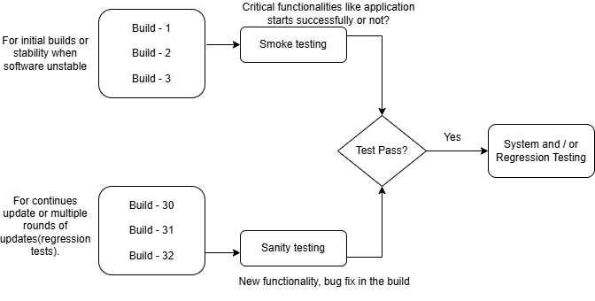
- Difference between verification and Validation
Verification | Validation
Verification refers to the set of activities that ensure software correctly implements the specific function | Validation refers to the set of activities that ensure that the software that has been built is traceable to customer requirements.
It includes checking documents, designs, codes, and programs. | It includes testing and validating the actual product.

- Explain types of Performance testing
- What is Error, Defect, Bug and failure?
Error : A mistake in coding is called error
Defect : Error found by tester is called defect
Bug : Defect accepted by development team then it is called bug
Failure : Build does not meet the requirements then it is failure
- Difference between Priority and Severity
- What is Bug Life Cycle?

- Explain the difference between Functional testing and Non-Functional testing
Functional Testing | Non-functional Testing
It verifies the operations and actions of an application. | It verifies the behavior of an application.
It is based on requirements of customer. | It is based on expectations of customer.
It helps to enhance the behavior of the application. | It helps to improve the performance of the application.
Functional testing is easy to execute manually. | It is hard to execute non-functional testing manually.
It tests what the product does. | It describes how the product does.
Functional testing is based on the business requirement. | Non-functional testing is based on the performance requirement.

